Assume that you have some new data that you want to explore. The new CRAN  
version of the ‘ExPanDaR’ package helps by providing a (customized) R notebook  
containing all building blocks of an exploratory data analysis with a few  
clicks.

**Install the Package and Start ExPanD**

First, you need to install the package. I recommend installing the Github  
development version of the package as it fixes some small bugs that I  
discovered directly *after* submitting to CRAN (sigh…).

# Install the current development version

devtools::install_github("joachim-gassen/ExPanDaR")

# Install from CRAN

# install.packages("ExPanDaR")

Next, you start ExPanD(), the shiny app of the package that is designed for  
interactive data exploration. When you start ExPanD with the parameter  
export_nb_option = TRUE, it allows you to export an R notebook containing  
the current state of your analysis from within the ExPanD app.

To explore country-level CO2 emissions we will use the World Bank data that  
comes with the package but you can do the same with just about every data frame  
that contains at least two numerical variables by simply calling  
ExPanD(data_frame, export_nb_option = TRUE).

library(ExPanDaR)

ExPanD(worldbank, df_def = worldbank_data_def, var_def = worldbank_var_def,

export_nb_option = TRUE)

**Explore Your Data Interactively**

After a little bit of a wait, you will see a shiny app that lets you explore  
a country-year panel of World Bank data. Select some visuals to display the  
distribution of CO2 emissions, measured in metric tons per inhabitant  
(cO2_emissions_capita). You will see that the distribution is log-normal: Many  
countries have relatively low levels of emissions while few countries have very  
high levels. You can define a logged variant of cO2_emissions_capita in the  
app to see that this variable is more normally distributed.

Let’s assume that at some point, you are done interactively exploring the data  
and want to export your findings for future study. One thing that you can do is  
that you can save your current app choices (scroll down, hit save). For the  
lazy: The code below reads my choices and starts ExPanD with them so that you  
can follow the analysis below

config_co2 <- readRDS(url("<https://joachim-gassen.github.io/data/ExPanD_config_co2.RDS>"))

ExPanD(worldbank, df_def = worldbank_data_def,

var_def = worldbank_var_def,

config_list = config_co2, export_nb_option = TRUE)

**Export a Notebook Containing Your Analysis**

While this allows you to restart ExPanD with your current analysis at a later  
point, you most likely want to extend the analysis by hand, e.g. by estimating  
more refined models or by adding more visuals. For this, you can export a  
Notebook containing the analysis. To do so, scroll to the bottom of the ExPanD  
app and click on the button below.

You should be rewarded with a file download dialog, asking you to store a file  
named ExPanD_nb.zip. Store and unzip it wherever you like. It contains two  
files

* A notebook file ExPanD_nb_code.Rmd and
* a data file ExPanD_nb_data.RData containing data and variable definitions.

**Exploring the Notebook Code**

Use RStudio to open the notebook file. You can directly knit it  
(Preview/Knit to HTML) but in order to work with and extend it, it is useful  
to take a deeper look at its code first.

When you scroll down the notebook, you will see the chunk that creates the  
scatter plot. In my analysis, I used it to document that the log of CO2  
emissions per capita is almost perfectly proportional to the log of GDP per  
capita. See below:

df <- smp

df <- df[df$year == "2014", ]

df <- df[, c("country", "year", "ln_gdp_capita",

"ln_co2_emissions_capita", "region", "population")]

df <- df[complete.cases(df), ]

df$region <- as.factor(df$region)

prepare_scatter_plot(df, "ln_gdp_capita", "ln_co2_emissions_capita",

color = "region", size = "population", loess = 1)

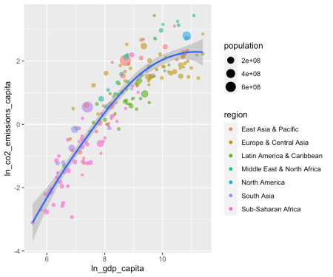

You see that the code of the chunk uses prepare_scatter_plot() of the  
‘ExPanDaR’ package to quickly produce a scatter plot visualizing up to four data  
dimensions.

for more information on how to use the EDA functions that come with the package.  
Also, you can always take a look at their code (just call their name without the  
brackets) to see what they do under the hood and to extend or modify them.

**Modifying and Extending the Notebook**

The finding above makes intuitive sense. Economic activity uses resources. Thus,  
we would expect countries with higher levels of economic activity to generate  
higher levels of CO2 emissions. As you can see above, the analysis is based on  
observations from 2014. Based on our argument above, the relation should also  
hold over longer periods. Let’s see how it looks like when we look at 1980. To  
do so, just copy and paste the chunk above and change the sample screen to be  
"1980".

df <- smp

df <- df[df$year == "1980", ]

df <- df[, c("country", "year", "ln_gdp_capita",

"ln_co2_emissions_capita", "region", "population")]

df <- df[complete.cases(df), ]

df$region <- as.factor(df$region)

prepare_scatter_plot(df, "ln_gdp_capita", "ln_co2_emissions_capita",

color = "region", size = "population", loess = 1)

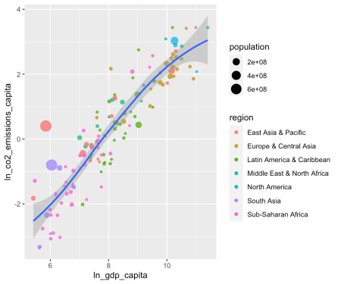

Seems to be the case. How does it look when we use all data (just remove the  
screen)?

df <- smp

df <- df[, c("country", "year", "ln_gdp_capita",

"ln_co2_emissions_capita", "region", "population")]

df <- df[complete.cases(df), ]

df$region <- as.factor(df$region)

prepare_scatter_plot(df, "ln_gdp_capita", "ln_co2_emissions_capita",

color = "region", size = "population", loess = 1)

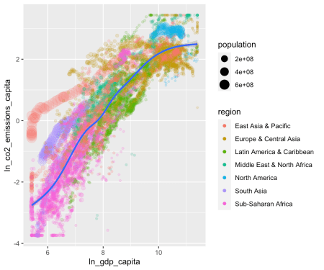

Looking at the whole data frame, the trajectories of the individual countries  
become apparent. The big red caterpillar to the left is China, the purple one  
below that is India and the Blue blob in the upper right is the U.S. This calls  
for a niced-up “Hans-Rosling-style” animation. Let’s do this.

library(gganimate)

iso3c <- worldbank %>% select(iso3c, country) %>% distinct()

df <- smp %>% left_join(iso3c, by = "country")

df <- df[, c("iso3c", "country", "year", "gdp_capita",

"co2_emissions_capita", "region", "population")]

df <- df[complete.cases(df),] %>%

filter(year <= 2014) %>%

group_by(country) %>%

mutate(nobs = n()) %>%

ungroup() %>%

filter(nobs == max(nobs))

df$region <- as.factor(df$region)

df$year <- as.integer(as.character(df$year))

df$population <- df$population / 1e6

aplot <- ggplot(df, aes(gdp_capita, co2_emissions_capita,

size = population, colour = region)) +

geom_point(alpha = 0.7) +

scale_x_log10(labels = scales::comma) +

scale_y_log10(labels = scales::comma) +

scale_size_continuous(labels = scales::comma) +

labs(title = 'Year: {frame_time}',

x = 'GDP per capita [2010 USD]',

y = "CO2 emissions per capita [metric tons]",

color = "Region",

size = "Population [million]") +

theme_minimal() +

geom_text(data = subset(df, population > 50), aes(label = iso3c),

nudge_x = 0.1, nudge_y = 0.1, size = 2) +

transition_time(year) +

ease_aes('linear')

animate(aplot, start_pause = 20, end_pause = 20)

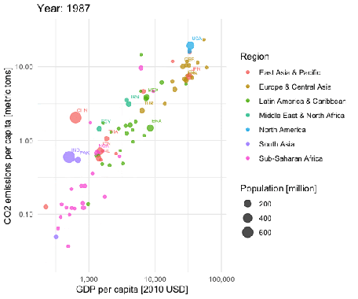

You see that most of the countries are moving to the upper right over time. This  
is good (higher economic productivity) and bad (higher CO2 emissions per capita)  
at the same time. Only very few European countries seem to be moving slightly  
downwards in later years, indicating reducing CO2 emissions per capita.  
It is a pity that the CO2 data provided by the World Bank currently stops in 2014.

Anyhow, you see that a notebook generated with a few clicks based on the interactive  
ExPanD analysis can serve as a starting point for a more in-depth analysis.  
Now it is your turn. Feel free to modify and extend your analysis along all  
possible dimensions. Code away and enjoy!